Web Service

The primary role of the web service is to serve as the interface between the web administration interface/database and the Android application. It works by acting as a REST API, allowing the Android application to make HTTP GET requests, where the contents returned are determined by the HTTP URL. The content returned is in the JSON format.

The main web application is titled ‘curator’. The initial functionality focus on serving up information related to the museum itself, as opposed to the museums content. Each museum in the database, which uses PostGreSQL, has a primary key which is an integer. Thus the following URL “*curator/1”* will return the information related to the museum object with the primary key of 1. The URL *“curator/”* will return a list of the all the museums.

Museum Object

* Model
  + Searchable fields
    - *primary key*
    - *city = models.CharField(max_length=200)*
    - *state = models.CharField(max_length=2)*
* Web API and Museum objects, the

To access a museum model you must have it’s primary key value. To obtain the primary key, you must first have the city and state of the museum. You can then use the API in the following manner:

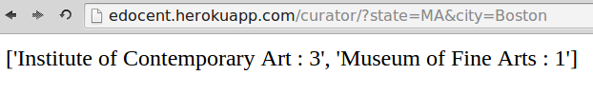

As can be seen, the API returns a list of museums with their associated names and primary. With the primary key, the museums direct information can then be accessed:

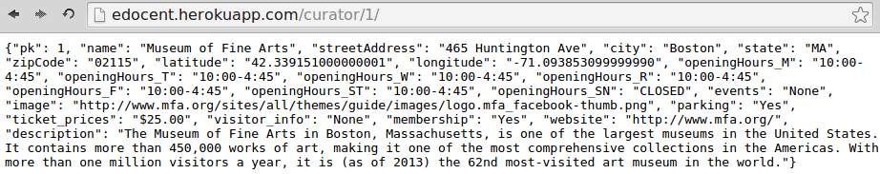

Locations API

To find the museums based on State and then city, the locations API call can be made as follows:

Exhibitions API

The museum can display its exhibitions, you can make the following API call:

*curator/museumID/exhibitions*

